
PRESS RELEASE Prague, 5 February 2019

You will enjoy good food and more in BB Centrum in February

After Christmas, we all entered the New Year rested and full of new energy. We gradually started to lose that over time, however, and it is necessary to renew it. You can do so at any of BB Centrum’s February events, which are held by PASSERINVEST GROUP and are meant for the general public and the tenants of the office buildings. Stop by BB Centrum!
7. 2. An Evening of Travel on the theme of Morocco
14. 2. The sweet life in BB Centrum
28. 2. Masopust Carnival in BB Centrum
The weather behind the window is still wintery, the sun only makes an appearance sometimes, almost like an afterthought, and there is still a long way to go until summer. When it is not possible to enjoy summer temperatures outside, visitors to BB Centrum will at least be able to transport themselves to a warmer clime through a travel lecture. In another of the popular Evenings of Travel held on Thursday, 7 February in KOBE restaurant, photographer and traveller Jana Kupčáková will take the listeners to sunny Morocco and show them the beauty of the seacoast, the arid desert and, for example, the loud traditional bazaars.
The following week, those who enjoy sweet confections will come into their own. On 14 February there will be a celebration of Saint Valentine’s Day on Brumlovka Square in BB Centrum. Starting from eleven o’clock until six in the evening there will be stands with sweet refreshments, tasty beverages and a wide assortment of flowers available for visitors, who will also find a thematic photo booth, live music and an accompanying programme for children.
The end of the month will be in the colours of the Masopust Carnival, which will get underway on Thursday, 28 February on Brumlovka Square. There will be stands with genuine Masopust food in the form of fried jelly doughnuts or potato pancakes, along with other popular traditional snacks and beverages connected with this festivity on the eve of spring. Children will be able to decorate their own carnival masks and even dance in them a bit during the Carnival celebrations. Jakub Xavier Baro will play on his guitar for visitors, both young and old, who can also look forward to a clown performance.
You can find more information and an overview of events on BB Centrum’s Facebook page.

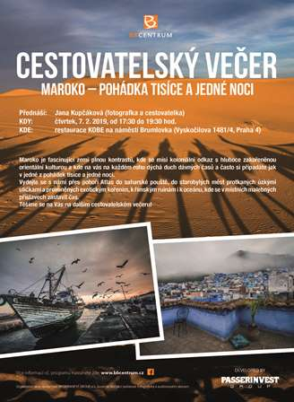

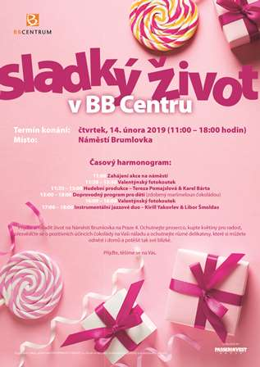

You can get more information and photographs in print quality from:
Kristýna Samková, Head of PR and Marketing Department
PASSERINVEST GROUP, a.s.
Tel.: (+420) 221 582 111
Mobil: (+420) 602 186 708
E-mail: Kristyna.Samkova@Passerinvest.cz
www.passerinvest.cz, www.bbcentrum.cz

Marcela Štefcová
Crest Communications a.s.
Mobile: (+420) 731 613 669
E-mail: marcela.stefcova@crestcom.cz

About the developer

PASSERINVEST GROUP, a. s. is a purely Czech development and investment company, whose name is primarily connected with the realisation of the multifunctional BB Centrum complex in Prague 4 – Michle. The company, established by Radim Passer in 1991, built a very good reputation both on a local and international level with this, the most successful and extensive project of its kind in Central Europe. This is not only to the credit of the quality of the realised projects and the high level of the provided services, but also due to the sense of fair play, an accommodating relationship with the buildings’ tenants/users and responsibility to the society and the environment. PASSERINVEST GROUP also has other interesting development projects in its portfolio.

